DevEx as a Service - Building Platform Teams
We ask a lot of DevOps teams.

The days of running software on relatively unchanging platforms are over, with cloud-native technologies and cloud providers iterating and expanding their offerings at a breathtaking pace. The Cloud Native Computing Foundation (CNCF) landscape looks like the periodic table if the periodic table had over a thousand elements. Meanwhile, cloud providers host annual conventions proudly announcing dozens of new headline features. It would be a dull convention if they didn’t.

New paradigms like GitOps, DevSecOps, and DevTestOps have entered our lexicon, often with nebulous definitions but having enough gravitas to be cited and funded as part of corporate strategies.

Metrics derived from large-scale research programs like DevOps Research and Assessment (DORA) measure the performance of DevOps teams. These metrics show short release cycles, fast release cadences, low failure rates, and quick recovery from failure are the hallmarks of high-performing teams.

The shift-left mindset accepts that discovering errors in production code is costly and damaging and encourages DevOps teams to identify and rectify these errors earlier in their lifecycle.

DevOps teams also face a hostile environment. The Department of Homeland Security noted in its 2022 year review that “the threat of cyberattacks from adverse nation states and criminal actors has only increased.” These threats exploit vulnerabilities, with high-profile examples like those discovered in Log4J, which left many teams scrambling to identify if they were affected and to deploy fixes, often at a high cost.

Individuals can expect a long and prosperous career gaining expertise in any one of these areas. So it is no wonder that asking DevOps teams to tackle all of these scenarios, in addition to their regular duties, has yielded unsatisfactory results.

DevOps teams understand that ad-hoc solutions to these challenges do not scale over the long term. The inability to scale proven solutions has given rise to platform engineering, whose goal is to develop scalable solutions that improve the efficiency and well-being, or Developer Experience (DevEx), of DevOps teams.

In the same way that cloud providers offer self service low level infrastructure such as virtual machines and networking as Infrastructure as a Service (IaaS), more specific services like web application or container hosting as Platform as a Service (Paas), and high level application as Software as a Service (SaaS), platform teams offer DevEx as a Service (DEaaS).

The specific technologies platform teams used to provide DEaaS form the Internal Developer Platform (IDP). An IDP encapsulates business goals, best practice, and hard-won practical experience in a scalable internal product, providing DevOps teams with a self-service platform to implement trusted and opinionated solutions.

This book provides advice for the founding members of a platform team during the early stages of implementing your platform engineering strategy, as well as practical checklists to facilitate discussions and guide decisions. Completing the sample checklists ensures that you have a clear understanding of the value your platform team provides to the business, the improvements your IDP will introduce to DevOps workflows, how you interact with and support internal customers, and what trade-offs are required to ensure the long-term success of your IDP.

Platform Engineering vs. DevOps
You can find many resources dedicated to DevOps, yet the concept is very frustrating for those who have had to apply it meaningfully. To understand why DevOps has become so contentious, we will investigate it by exploring the counterfactual "What is DevOps not?"

What is DevOps Not?

The image below depicts a common interpretation of the DevOps lifecycle:
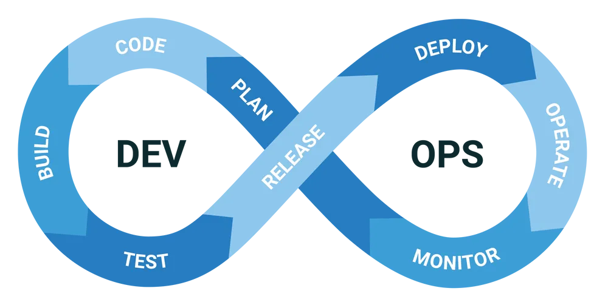

This image shows that DevOps encompasses planning, writing, testing, deploying, monitoring, and supporting software. The DevOps lifecycle is perhaps best summed up by a quote from Werner Vogels, Amazon's CTO, who said in 2006, "You build it, you run it."

We then have measurements that gauge the performance of DevOps teams. The DORA Accelerate State of DevOps report has five key metrics: deployment frequency, lead time for changes, change failure rate, time to restore service, and reliability. These are referred to as the DORA metrics. It also links organizational performance to the characteristics described by Westrum's organizational culture (https://oc.to/r2TWX0), where generative cultures high in trust and low in blame exhibit higher performance.

These definitions show us that the processes and cultural foundations that support and improve the delivery of features, reduce defects, and reduce the time to resolve issues all contribute to the foundation of DevOps.

And these are just two of the more popular interpretations of DevOps. One of the great successes of the DevOps movement is that it encourages new perspectives on the metrics, processes, ideals, and cultural underpinnings of the field.

But even with just the DevOps lifecycle, DORA metrics, and Westrum organizational culture, we can attempt to answer the question “What is DevOps not?”

There is no satisfying answer to that question. The term DevOps has become almost unfalsifiable, but this is quite by design. DevOps has unashamedly sought to break down the silos that previously separated teams responsible for creating and delivering technical solutions, while simultaneously building a culture of psychological safety to empower teams to deliver creative solutions. The ideal DevOps team is self sufficient, with the ability, willingness, confidence, and responsibility to tackle any problem.

But for every ideal DevOps team thriving on the responsibility to own their own destiny, there is another team slowly drowning under the constant need to resolve every brittle process they encounter in the DevOps lifecycle. The mental burden of this undifferentiated and unsatisfying work has come to define their existence, leading to a downward spiral of dispirited and low performing teams. Or, put more simply, teams with an unsatisfactory developer experience.

What is Platform Engineering?

If DevOps encapsulates literally everything that is required to deliver a technical product to a customer, then platform engineering is the catalyst to initiate and facilitate DevOps processes. By delivering DevEx as a Service through an IDP, platform teams improve the velocity of DevOps teams, increase the quality and consistency of their work, remove points of friction that DevOps teams find so frustrating, and do so in a repeatable and scalable manner.

By aligning itself with established paradigms like IaaS, PaaS, and SaaS, DEaaS expresses the goal of platform engineering (improved DevEx) and its method of delivery (a self-service IDP).

Describing platform engineering in terms of DEaaS also allows platform teams to identify whether their work contributes to the goal of platform engineering or if it is more aligned with the kind of Business as Usual (BAU) work often performed by DevOps teams. This avoids the unfalsifiability of DevOps. The difference between DEaaS and other tasks is whether the work can be used to spin up a new project or team.

Consider that every major Operating System (OS) these days has the ability to host VMs. Does that mean you have implemented IaaS by giving every engineer a device with a modern OS? Of course not. IaaS requires the ability to provision a durable, accessible, supported, and monitored VM on demand, or at least with as little friction as possible.

In the same manner, if spinning up a new project or team involves recreating processes and infrastructure from memory or reverse engineering settings from existing code bases and established systems, you have not implemented platform engineering. This is true even if your work has been to improve DevEx by streamlining processes or refine the state of established platforms, as the knowledge about what decisions were made, and why, is only held in the heads of a few key members of the DevOps team.

On the other hand, if you can leverage your IDP to spin up a new project or team, with confidence that best practices and hard won business knowledge is baked into the foundation your IDP provides, then you have successfully implemented platform engineering. This one-to-many relationship between an IDP and the processes used by DevOps teams demonstrates that architectural decisions are centrally defined and can be implemented on demand.

I have spent literally years tweaking my workstation to streamline my workflows. I now have a nice collection of scripts, kernel settings, application customizations, and browser extensions to solve common problems and let me focus on useful work. This is a clear example of focusing on DevEx, but it is not an example of platform engineering, because a new colleague could not readily recreate my environment. In fact, I’m not even sure I could readily recreate my environment either. Understanding all the decisions that went into an established system is like trying to deduce the colors that were mixed to produce a tin of paint. The paint tin analogy holds even though I would have been the one to originally mix the paint!

Conclusion
DevOps is arguably the best philosophy we have to build high performing teams to deliver technical solutions. But just because DevOps can build great teams, there is no guarantee that it will.

Platform engineering is an acknowledgment that common problems are best solved with common solutions, and that solving common problems is one of the most effective methods for improving DevEx.

By delivering DevEx as a Service, platform teams are responsible for an IDP that ensures architectural decisions, best practices, and business knowledge is codified and able to be implemented at scale throughout DevOps teams. This one-to-many relationship between an IDP and DevOps processes is a clear sign that you are doing platform engineering right.

The Value of Platform Engineering
Despite being a relatively new field, studies, articles, and anecdotes demonstrate this paradigm's value to engineering organizations.

This chapter is most useful for organizations considering establishing a platform team, as such a request requires a compelling argument for funding. It is essential to relate the value of a product team and the IDP they create back to business goals. Supporting those arguments with industry survey results and external examples of success gives you credibility. It provides those who fund this team confidence that platform engineering is not a fad.

Platform Engineering by the Numbers
The HashiCorp “2023 State of Cloud Strategy Survey” report (https://oc.to/vr6S2Q) notes that:

The presence of a centralized platform team is a foundational element of a well-rounded multicloud strategy.

The report then says:

Platform teams are a key pillar of operational maturity. These centralized hubs effectively manage people and standardize processes, but organizations need skilled professionals to staff them. Those without platform teams cited a lack of skills/staff (36%) as the reason why they hadn’t put one in place to manage their cloud strategy — a rise of 14 percentage points from 2022’s State Of Cloud Strategy Survey.

The Puppet “State of DevOps Report Platform Engineering Edition 2023” (https://oc.to/7O5fqO) reports that 68% of respondents saw an increase in development velocity after implementing a platform team. In addition, 93% of respondents reported that development speed after the inception of a platform team increased “A great deal” or “somewhat”, with only 5% reporting “very little”.

Platform teams also improved DevEx, with the report showing that:

Most notably, respondents at firms with platform engineering in place are more likely to identify as “very satisfied.”

In his presentation “Why did you build an Internal Developer Platform at GitHub?” (https://oc.to/ItKChg), Jason Warner, CTO of GitHub, notes that scaling processes with people was not a viable option:

When we hit that scale on operations, or the infrastructure team, [who were] responsible for coordinating all those things that were happening and how to release it, it was unmanageable.

You couldn’t scale that with people.

Eugene Kim of Insider (https://oc.to/8V7w5I) reported the efforts of Amazon CEO Andy Jassy to fix a crumbling engineering culture with a new unit called Amazon Software Builder Experience (ASBX). The article notes the engineering team's frustrations:

In a recent internal survey, seen by Insider, 34% of the engineers said they spent 4 to 8 hours on undifferentiated efforts weekly, or roughly 10% to 20% of their week on things that are not related to building new products. Another survey found that engineers spend 30% of their time on "repetitive tasks."

The article goes on to list the six tenants used by the ASBX team:

- Software builders across Amazon require consistent, interoperable, and extensible tools to construct and operate applications at our peculiar scale; organizations will extend on our solutions for their specialized business needs.
- Amazon's customers benefit when software builders spend time on novel innovation. Undifferentiated work elimination, automation, and integrated opinionated tooling reserve human interaction for high judgment situations.
- Our tools must be available for use even in the worst of times, which happens to be when software builders may most need to use them: we must be available even when others are not.
- Software builder experience is the summation of tools, processes, and technology owned throughout the company, relentlessly improved through the use of well-understood metrics, actionable insights, and knowledge sharing.
- Amazon's industry-leading technology and access to top experts in many fields provides opportunities for builders to learn and grow at a rate unparalleled in the industry.
- As builders we are in a unique position to codify Amazon's values into the technical foundations; we foster a culture of belonging by ensuring our tools, training, and events are inclusive and accessible by design.

While the ASBX team doesn't specifically describe itself as a platform team, a focus on "undifferentiated work elimination, automation, and integrated opinionated tooling", the relentless improvement of "software builder experience", and "codifying" organizational values all speak to the principals of a platform team.

More than the specific highlights above, the most valuable thing to take away from this chapter is the existence of reports and industry examples that quantify the value of platform teams and IDPs. These examples are invaluable to have in your back pocket when quantifying the value of a platform team.

Quantifying the Business Value

There are many ways to demonstrate the potential value of a business proposal. But, as we'll discover in the "Planning your Internal Developer Platform" chapter, the initial members of a platform team are likely to be generalists rather than seasoned salespeople, so we'll need a straightforward methodology to articulate the business value of a platform team.

The post “Identified Pain Is About Customer Outcomes” (https://oc.to/iktukN) lists four concerns, or pain points, that all business initiatives must consider:

- Revenue – is there a pain impacting their booking revenue? Does your solution solve this pain?
- Cost – is there a pain driving up the cost of doing business? Can your solution solve this pain?
- Risk – is there a new regulation they are in danger of breaching? Does your solution mitigate the pain?
- Shareholder Commitments – have they committed to something to their shareholders, which without your solution they will fail to deliver?

Any new initiative must ultimately impact one or more of these concerns, where risk and cost decrease while revenue increases. It is harder to show independent increases to shareholder value, but it is included here for completeness.

Emma Maslen, the author of the post above, included shareholder value to capture cases where businesses were working towards efforts like environmental initiatives or diversity, equity and inclusivity that may not necessarily impact risk, cost, or revenue. In most cases, shareholder value is a consequence of changes to the other three pain points.

The chapter “Planning your Internal Developer Platform” notes that a clear mission and focus are vital to a successful IDP implementation. The mission statement is also an opportunity to address one or more of these four pain points.

Fortunately, an IDP has plenty of scope to impact business value positively. By infusing best practices at scale throughout your DevOps teams, it is reasonable to argue that your IDP directly reduces friction, improves DevEx, improves deployment frequency, or improves compliance. Importantly, these improvements are repeatable and scalable. The final step is to describe these improvements in terms of business concerns like risk, cost, or revenue.

Unlike the mission statement, the business value captured in this process must be expressed as a number to ensure it is measurable. Defining measurable values involves answering questions like:

- How much money will be earned from new features delivered as a result of the increased performance of the DevOps teams?
- How much reputational risk is reduced by standardizing security practices across all projects?
- How much money will be saved by removing the need for DevOps teams to manually respond to a newly published CVE?
- How many fewer staff members will leave DevOps teams in a year if 20% of undifferentiated work is removed?

Metrics and numbers can be sensitive subjects and it is easy to impose arbitrary values on people who may not appreciate the implications. Pia Nilsson, Lead Platform Developer and Experience Lead at Spotify, noted in her talk "Developer Enablement at Spotify" (https://oc.to/BXqhGK) that co-creating metrics has been a successful approach:

I think the way I've seen it successful, and it took us a few years to get this right too, is to really go to the organization within your company, approach these leaders with empathy [...], and help them co-create metrics that would matter to them.

Spare Time Platform Teams
A common symptom of an organically grown platform engineering strategy is spare-time platform teams, usually comprised of a few enthusiastic engineers who tackled the technical aspect of an IDP and who demonstrated enough value within their immediate orbit to justify maintaining it, if only in an ad-hoc manner.

Spare-time product teams can do fantastic work. As Eric S. Raymond teaches as the first lesson in "The Cathedral and the Bazaar" :

Every good work of software starts by scratching a developer’s itch.

However, such teams are one reorganization away from being dispersed amongst their broader DevOps ecosystem, which makes them fragile. Clearly articulating the business value of a platform team makes it more resilient to changing business conditions.

Example Checklist
The checklist below provides a simple example describing how an IDP may positively impact core business requirements.

Business Concern | Impact
Risk | An internal review identified 15 dependencies used in production applications rated as critical. These vulnerabilities expose the company to data breaches and denial of service attacks. The current process of discovering vulnerabilities is reactive and ad-hoc, leaving production applications vulnerable for many months.  An IDP that provides CI/CD pipelines including standardized security scanning steps allows DevOps teams to identify which applications have vulnerable dependencies within 1 day of vulnerability reports being publicly released.
Cost | Exit surveys indicate that undifferentiated work contributed to 20% of those who quit last year. By reducing undifferentiated work, the IDP aims to reduce staff turnover and the cost of training new staff by $100,000 annually.
Revenue | New features took, on average, six months to be released to customers last year, with 17 lost opportunities due to missing product functionality.  DevOps teams have identified that time spent waiting for infrastructure provisioning contributed at least four weeks to this release time.  By exposing self-service infrastructure provisioning, the IDP aims to reduce release times by 10%, allowing up to 3 new features to be released per year, resulting in the completion of 5 additional deals worth 75k per year.

Conclusion
Organizations looking to introduce a platform team must present a compelling business case for an IDP and the platform team responsible for it. This chapter provides insights into the benefits of platform engineering based on industry reports and distills business value down to three pain points to attach quantifiable value to.

Planning your Internal Developer Platform
It is tempting to think platform engineering has a simple, technical solution. Perhaps a YAML template for your Kubernetes cluster, a script for your CI/CD pipeline, or a custom web app providing a dashboard and internal registry of templates will solve the immediate requirements. But this narrow focus misses the opportunity a platform team can bring to your organization.

Platform engineering means building a Developer Experience as a Service platform. A platform team is effectively running an internal startup, which means you are not providing a piece of software but a complete service to your internal customers.

Running an internal startup can be daunting because platform engineering teams must draw from the work typically done by dedicated engineering, support, technical writing, training, product, and design teams. However, addressing a few key activities early in the inception of a platform team provides a solid foundation for future growth while retaining the agility required to keep pace with high-performing DevOps teams.

Building your Platform Team
It can seem like platform teams are saddled with the same do-it-all-yourself mentality as their DevOps customers. Indeed, in the early stages, platform engineering teams will attract generalists who enjoy tackling various challenges but with a clearly defined mission to avoid taking on an impossibly broad scope of work.

Over time, platform engineering teams evolve to incorporate the kind of specialized roles found in other product-focused engineering teams. The "State of DevOps Report Platform Engineering Edition 2023" (https://oc.to/7O5fqO) notes that:

At firms in which a platform team has existed for three or fewer years, 60% of respondents identify a need for a product manager; at firms in which a platform team has existed for more than three years, this number rises to 74%.

You can expect a successful platform engineering strategy to incorporate other specialized roles such as technical support, technical writers, security, and site reliability. That said, though, generalists will serve your initial platform well by being able to draw on experience from various backgrounds.

The Forbes article “Generalist Vs. Specialist Teams: How To Build A Highly Creative Startup” (https://oc.to/jkdl9C) notes that the unpredictable nature of startups does not support specialization:

In highly-predictable environments, specialization allows you to solve problems very efficiently. In unpredictable environments, however, efficiency isn’t as important as creativity. And the environment of innovative startups is anything but predictable.

The activities listed in this chapter support teams in the initial stages of their platform engineering journey. The aim is not to make the platform team experts in product management, marketing, technical writing, and training. Instead, these activities reinforce the need to treat platform engineering like a startup rather than a feature to be delivered in a sprint and provide a solid foundation for operating an internal product.

Mission and Focus
The platform team’s mission and focus are crucial to ensuring that you deliver the highest value solutions to your DevOps teams. Some examples of mission statements are:

- Enforce conformance by provisioning standard deployment pipelines for all microservices.
- Improve security and maintainability by enabling security scanning against all production deployments.
- Manage costs by providing the ability to create standardized cloud resources with self-service workflows.
- Standardize observability by adding monitoring capabilities to all public-facing applications.
- Increase reliability by automating fault detection and rectification for all Kubernetes applications.

The mission statement must capture the platform's functional requirements (what the platform will do) and non-functional requirements (capabilities that the platform will support, typically "ilities" like observability, scalability, and maintainability). It must also positively influence the business concerns listed in the "Quantifying the Business Value" section of cost, risk, revenue, and shareholder value.

You can find a comprehensive list of non-functional requirements on Wikipedia (https://oc.to/UD2mRM), while the chapter “The Ten Pillars of Pragmatic Deployments” documents non-functional requirements tailored to CI/CD pipelines.

A simple statement that defines the team's mission will provide context for all their subsequent activities, for example, by focusing your user interviews on pain points and aspirations related to the mission while triaging support and feature requests based on their alignment with the mission.

The mission statement also guards against the platform engineering team becoming a reactive, general-purpose support platform for wider DevOps teams.

User Interviews
Talking to your DevOps teams and their management is critical to understanding the opportunities for a platform team to improving DevEx. These conversations will quickly highlight the pain points in your company's current processes, as well as surfacing many aspirational goals.

Your IDP will be bought by your peers, not sold by their managers, so the people you interview are the same people you are trying to sign up for your internal startup. You will gain your customer's trust by taking note of their pain and wishes and repeating these observations as you talk about the goals and features of your IDP.

Courtney Kissler, ​​who led large-scale reorganizations and technology transformations at Starbucks, Nike, and Zulily, notes in her presentation “How to build internal platforms for the enterprise” (https://oc.to/V0pDUd) that:

Just because you build a platform doesn't mean people are going to consume it.

It has to solve a need, it has to be compelling, and you need to treat it like a product.

For those from an engineering background, talking to customers can elicit a feeling of dread. As an engineer, I never wanted to talk to customers because every customer I ever interacted with asked me to fix a bug or solve a problem. This order-taking was tolerable via asynchronous communication like email, but face-to-face conversation felt like an invitation for unbounded personal support, which was the last thing I wanted.

I wasn't necessarily wrong (I've had more than a few "I hope it is OK to email you directly, but I was wondering if you could …" emails after one-on-one conversations). Fortunately, internal user interviews are far more informal and enjoyable. They have proven to be a great way to build camaraderie and surfaced many wishes and requirements for our IDP.

Just as important as listening to your audience is the ability to challenge them with new ideas. Even if you have been granted the opportunity to build an IDP, user interviews are still as much about selling the benefits of an IDP as it is about gathering requirements (or, in other words, being an order-taker).

The Forbes article “Why Most Salespeople Are Order Takers And Not Sellers” (https://oc.to/VmnpgR) notes that:

Selling is about change, and it's salespeople's job to influence that change. Salespeople who can't influence change are simply order-takers.

Gregor Hohpe similarly notes in his book “The Software Architect Elevator” that modern IT departments have moved beyond order taking:

Positioning IT architecture on par with business architecture highlights, though, that the days when IT was a simple order-taker that provides a commodity resource at the lowest possible cost are (luckily) over. In the digital age, IT is a competitive differentiator and opportunity driver, not a commodity like electricity.

You are uniquely positioned as a platform team member to understand the different viewpoints held by your DevOps teams, to share those insights with a broader audience, and sell a vision for how an IDP can influence positive change in an organization. Remember, you are running a startup, not building a better conveyor belt.

For those platform engineering teams tasked with improving their CI/CD pipelines, the chapter "The Ten Pillars of Pragmatic Deployments'' lists typical deployment pipeline non-functional requirements. These provide valuable prompts to surface desirable qualities as you talk with your customers.

Documentation and Training
Your IDP is a tool that tool builders use. It integrates many other tools and platforms. It needs to be flexible, configurable, and customizable. In short, it is a bespoke product encapsulating and supporting the specific requirements of your internal teams and organization.

Your customers don't have the luxury of Googling how to use this internal tool, and there are no posts on Stack Overflow to point them in the right direction. The lack of external community support means your platform requires robust documentation and training for your internal customers to get the most out of it.

The success of your IDP can be measured by its ability to embed best practices more broadly than would be possible if individuals were to implement them within each team or project. This scale is only possible if DevOps teams can understand and implement the solution without requiring a personal demonstration every time. Documentation and training are two proven solutions for upskilling customers at a time and pace that suits them.

"Any product that needs a manual to work is broken." It's a catchy quote from Elon Musk, and yet the first time I caught a Tesla Model 3, my Uber driver had to open the door for me because I didn't know how the handles worked. Thankfully, and ironically, Tesla's online owner's manual has excellent documentation on how to open the doors. I'll know better next time.

Support
A considerable aspect of the ongoing operation of your platform engineering solution is the support you offer your internal customers. While it is tempting to think you'll have a captive audience with a mandate to use your platform, in reality, you are competing with how DevOps teams used to do things. If your IDP does not work as expected (which is inevitable at some point, given the scope of what platform engineering encompasses), you must have a responsive support channel. Otherwise, your customers will revert to their existing processes.

Your documentation and training efforts can significantly complement your support processes. Ideally, supporting your customers means pointing them to the documentation or training that answers their questions, addressing a bug, or accepting a feature request.

A responsive support layer is critical to prevent your solution from being the blocker a platform team should remove. Nothing is more detrimental to DevEx than the broken flow caused by a blocking issue and an unresponsive support team.

Note that being responsive is not the same as solving every problem. It is an anti-pattern to move all the pain to the platform team by expecting them to provide site reliability services, general advice, or function as a help desk.

Platform teams must balance many concerns while interacting with their customers:

- To provide internal customers with opinionated solutions.
- To support these solutions to prevent customers from being blocked.
- To encourage customers to implement their own solutions and incorporate those improvements into your IDP.
- To manage the potential expectation that the platform team will immediately support anyone with any issue.

The best way to maintain this balance is to clearly define levels of responsibility. This ensures the platform team and their customers have a clear understanding of who is responsible for maintaining the artifacts generated by an IDP. The chapter "Platform Engineering Responsibilities" discusses different responsibility models.

Issue Tracking and Feature Requests
The ability to track the status of issues discovered in your IDP and to track any progress with feature requests provides your customers confidence that bugs are being fixed and requests are taken seriously.

Your customers will be technical people familiar with issue-tracking platforms like Jira, GitHub, Bugzilla, etc. You will likely have an issue tracker already in use by your DevOps teams, and reusing it for your IDP is a natural choice.

Be confident enough to admit you must wait to implement new features. While working in product teams, I was overwhelmed with requests for new features and improvements and felt that confessing that we wouldn't consider even great ideas for at least 6 to 12 months was admitting defeat. Often, I just ignored these requests, but that was a mistake. Having been on the other side of that conversation, I'd prefer an honest answer to no answer.

Marketing
Building an IDP is a long-term commitment, and as you fix bugs, add features, or respond to changing requirements, you must be able to publish new and improved solutions to your internal customers.

Typically, your IDP will either push changes out to your customers or allow them to pull the changes as they are made available. If you opt for a pull-based approach, you'll need a method for notifying your customers of new features.

However, as impressive as your IDP may be, you will only reach the point of needing such a solution when your customers already have a dozen other platforms they need to use every day. One of the challenges of running a startup is respecting your customers' attention and not abusing that relationship with noise.

Most DevOps teams have an internal chat solution, which can be a low-friction method of announcing features or changes. Lunch-and-learn sessions are another excellent way to reach your internal customers. Also, consider recording a demonstration of the new features and sharing it as a monthly webinar.

One of the tips I learned when I moved to a sales team was the value of existing, general-purpose meetings preallocated in a team’s calendar. Never underestimate how hard it is to find a time for everyone to meet. Being able to present at a lunch-and-learn is an incredible opportunity for your marketing efforts.

Feedback
Feedback from your customers is crucial to understanding whether you are meeting their expectations.

There are many examples of embedding feedback into processes, including:
- Net Promoter Score (NPS)
- Customer Satisfaction Score (CSAT)
- Questionnaires

Remember, though, that high-quality feedback scores require an appropriate sample size. Unless many internal customers use your IDP, you may not be able to source feedback from enough people to generate meaningful scores.

In the paper “Belief in the Law of Small Numbers”, Kahneman and Tversky define the Law of Small Numbers as the mistaken belief that a small sample accurately reflects the probabilities of a population. With small sample sizes, those few customers who felt like providing feedback may unduly influence how well you believe all customers received your IDP.

The effort spent encouraging your internal customers to supply feedback may be better spent scheduling user interviews after releasing features or on a regular schedule. Compared to most product teams, you have the advantage of working side by side with your customers, and it would be a missed opportunity not to take advantage of this.

However, there is still value in offering a real-time feedback mechanism, if only to provide an outlet for frustrated customers to signal their displeasure. Just as most product teams would prefer to receive such feedback directly rather than second hand via channels like social media, platform teams benefit from the opportunity to resolve these issues directly rather than hear from the CTO that their IDP is not meeting expectations.

A common pattern I have noticed in many mobile apps is a two step feedback process. The first question is designed to gauge whether the customer would provide a positive or negative rating. Those that indicated they would provide a negative rating are redirected to an internal feedback channel, while those providing positive feedback are forwarded to the public app store.

So while low-touch feedback methods like NPS and CSAT scores may not provide reliable metrics with small sample sizes, it is still worth collecting this data. Conversations with customers are where you will find the actual value. But offering a way to submit negative feedback provides platform teams the opportunity to quickly resolve, or at least understand, points of friction. Meanwhile, any positive feedback is marketing gold, regardless of the statistical significance.

Example Checklist
The following checklist is an example that documents how you might address the activities noted in this chapter. As you can see, this example checklist is not complicated, but it does commit the platform team to:

- Defining the mission statement
- Selecting individuals for user interviews
- Writing introductory documentation
- Creating onboarding training
- Selecting support and notifications platforms
- Committing to regular internal announcements to demonstrate new features
- Planning follow-up user interviews at regular intervals to gain feedback

Process | Plan
Mission | Enforce conformance by provisioning standard deployment pipelines for all microservices.
User Interviews | - Jane Smith  - Sunita Singh  - Lin Zhou  - Mike Jones
Documentation | Getting Started guide in GitHub Wiki
Training | 5-part video training series:  - Creating the first deployment project  - The features required in every project  - Customizing the project  - Updating the project with upstream changes  - Getting support and requesting features
Support | - #platform-engineering in Slack
Issue tracking | GitHub issues:  - Issues tagged with “bug”  - Feature requests tagged with “enhancement”
Marketing | - A channel announcement in #platform-engineering  - A summary of new features in the monthly lunch and learn session
Feedback | Provide thumbs up/down links at the end of each deployment.  Schedule calls with five users from each team 1 month after the initial release and every six months after that.

Conclusion
This chapter reinforced the importance of treating your platform engineering initiative as an internal startup within your company. You are not building a feature but instead creating an end-to-end solution with all the business processes customers would expect from any business-critical application they adopted for their day-to-day operations.

Platform engineering is not a trivial undertaking, but for those lucky enough to be involved, it is an exciting opportunity to run a business in a business.

The activities listed in this chapter precede any discussion about implementing an IDP. Prioritizing these activities is quite deliberate and highlights the importance of planning for success before implementing the solution. The example checklist provides an easy way to ensure these requirements are tangible and not afterthoughts.

Platform Engineering Responsibility Models
A primary goal of any platform team is to never block internal customers from achieving their goals while providing solutions that remove the need to reimplement solved problems.

This quote from Peter Gillard-Moss of Thougtworks in the blog post “Platform Tech Strategy: The Three Layers“ (https://oc.to/Ka3d7I) sums it up nicely:

Platforms are a means of centralizing expertise while decentralizing innovation to the customer or user.

We can also draw inspiration from the definition of "architecture" from “Objects, Components, and Frameworks With UML: The Catalysis Approach” by Desmond D'Souza and Alan Wills (https://oc.to/sjdtWf):

The set of design decisions about any system (or smaller component) that keeps its implementors and maintainers from exercising needless creativity.

These quotes show that the platform team aims to give customers the freedom to innovate while discouraging the tendency to indulge in the "needless creativity" often associated with delivering new solutions to already solved problems.

Achieving this balance requires deliberate decisions about who has responsibility for artifacts generated by your IDP. This chapter explores the three common ways in which responsibility is assumed by, or shared with, the platform team and your customers.

Customer Responsibility
The easiest way to think about customers taking responsibility for the artifacts generated by your IDP is to think of copying a template document from a read-only shared drive into the customer’s home directory.

While you must make every attempt to ensure the template is fit for purpose and of high quality, once a customer makes a copy, they assume responsibility for using, editing, and updating that copy. Existing copies do not receive updates to the source template document.

In the same way, the IDP does not provide updates for artifacts like sample projects or scripts, deployment pipelines, or example dashboards. The platform team only supports them in a limited fashion once a customer has taken ownership under a customer responsibility model.

This model reduces the likelihood that the platform team will block their customers. If the artifacts are insufficient or require change, customers have the freedom and responsibility to do it themselves.

The downside to this model is that it does not allow for automatic updates to artifacts generated by the IDP. The disconnected nature of artifacts distributed under the customer responsibility model limits the ability of the platform team to propagate improvements.

Heavily modifiable artifacts are well suited to this model. For example, a "hello world" style software project template that embeds standard settings, like dependency repositories, common build scripts, and a skeletal folder structure, is an ideal candidate for the customer responsibility model, as customers will drastically alter this project template almost immediately.

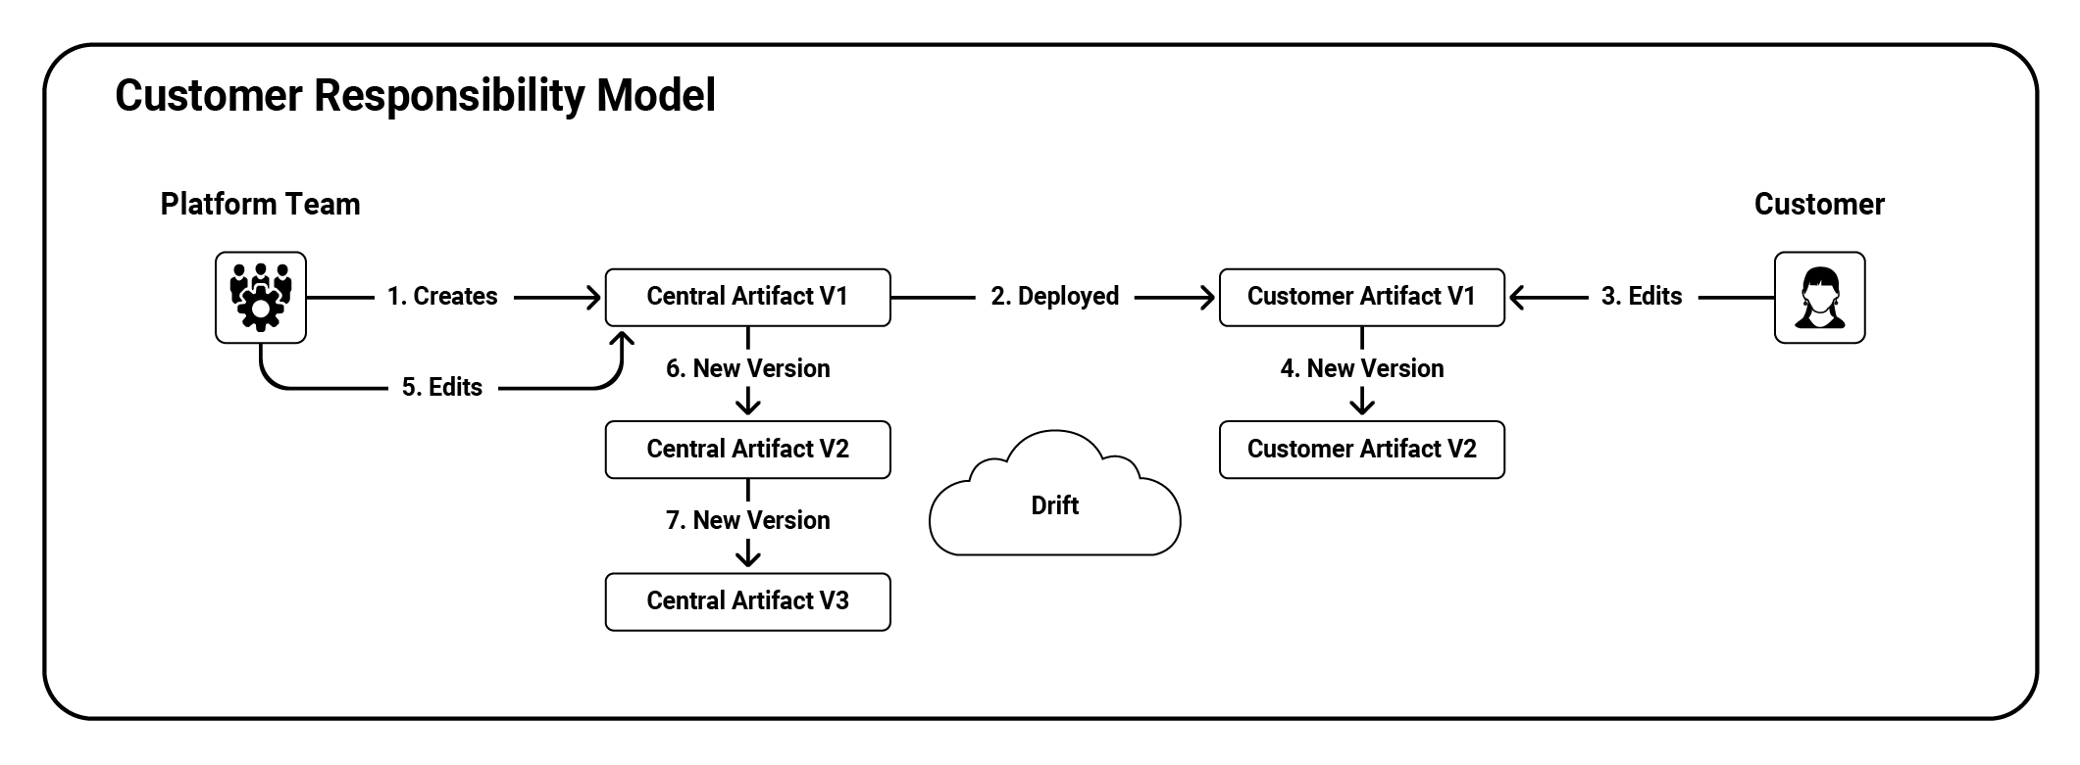

Shared Responsibility
The shared responsibility model allows the customer and the platform team to modify an artifact after creation. An example of this model is the process of forking a Git repository. Because both Git repositories share the same history, it is possible to merge changes between them while retaining any local changes.

This model may involve the platform engineering team pushing changes, the customer pulling modifications, or both.

Git is an excellent example of the shared responsibility model and one of the most practical ways to implement it. The merging strategies implemented by Git do an excellent job of tracking changes (as opposed to simply finding differences between files). By having your IDP generate Git repositories as artifacts, it becomes possible to merge the downstream (or customer controlled) repositories and upstream (or platform team controlled) repositories.

Git is not a requirement to implement the shared repository model, though. A regular diff between two plain text files may be sufficient for customers and the platform team to consolidate changes made by each other. As a fallback, good old copy and paste may suffice to synchronize changes.

Like the customer responsibility model, the shared responsibility model helps prevent the platform team from being a blocker, as customers have the ability and responsibility to update their artifacts to resolve any issues.

The shared responsibility model can propagate changes from artifacts maintained by the platform team to those maintained by the customer.

However, be aware that it may not be reasonable, or even possible, to propagate changes to heavily modified customer artifacts. In these situations, there will need to be an agreement on who does the work of merging changes. Customers may be happy to pull in changes as required, or the platform team may need to do the work to push changes out.

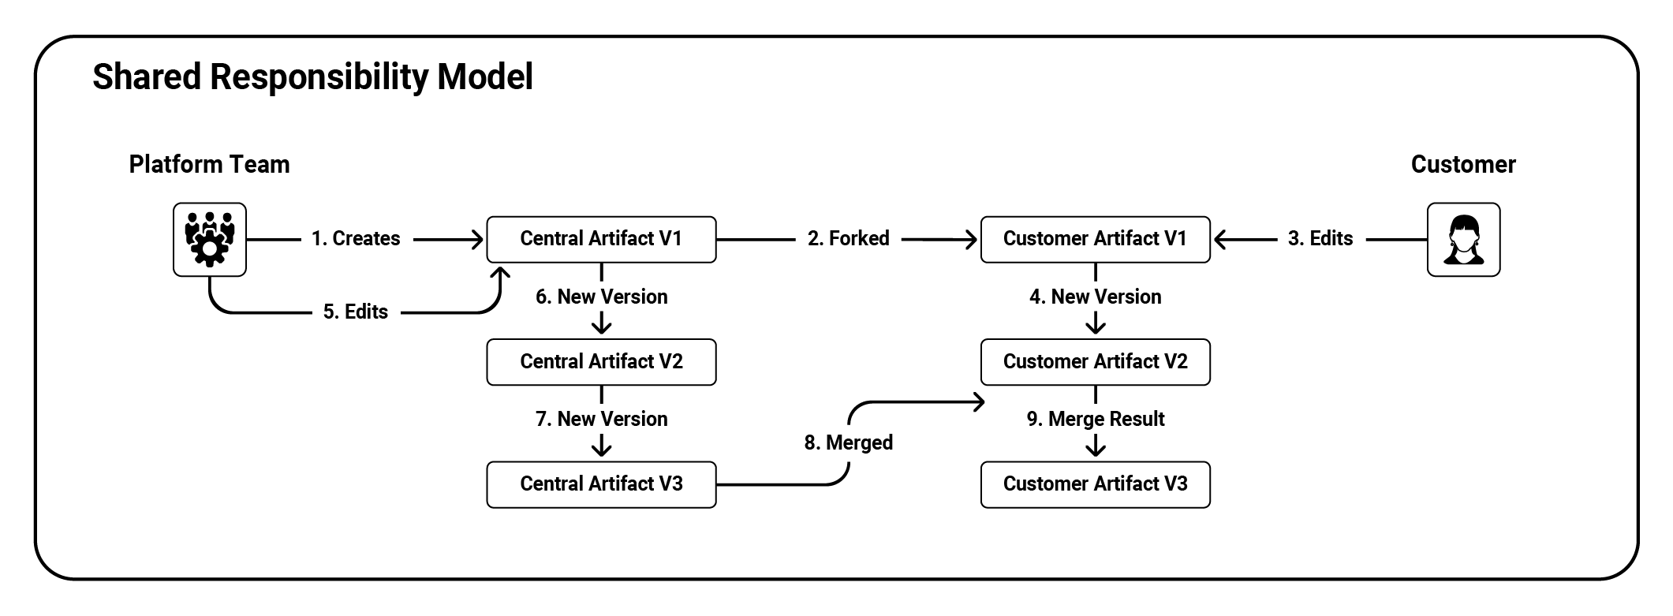

Centralized Responsibility
The centralized responsibility model gives customers read-only or locked-down copies of any generated artifacts. While customers are free to use these artifacts, they have little or no ability to edit them.

An analogy is a virus scanner deployed to your workstation by the security team. You can run the virus scanner, but you cannot configure it. A central team manages any updates to the virus scanner or its configuration.

In the same way, customers can use a deployment pipeline distributed under the centralized responsibility model to deploy their software, but they cannot edit the pipeline.

The centralized responsibility model allows the platform team to push out changes quickly. Because the artifacts are always in a known state or the platform team can overwrite any changes, it becomes much easier to update artifacts at scale. This model is easy to implement with common Infrastructure as Code (IaC) tools like Terraform, CloudFormation, and Azure Arm Templates.

The downside to this model is that you risk blocking your customers. If the artifacts you provide have faults or limitations, it is entirely up to you as a platform team member to push out updates to unblock your customers.

This model suits simple and extensively tested artifacts, such as scripts to perform backups or restart services. Unfortunately, this model tends to fail when distributing more complex artifacts. As Gregor Hohpe put it in his presentation "The Magic of Platforms" (https://oc.to/bWjWFK):

There are two ways to build a platform:

- Be smarter than everyone else and anticipate all their needs
- Evolve the platform based on user needs, which can be sensed from platform usage

One is more likely than the other.

As your IDP gains traction, your customer's requirements will test the bounds of complex artifacts distributed under the centralized responsibility model.

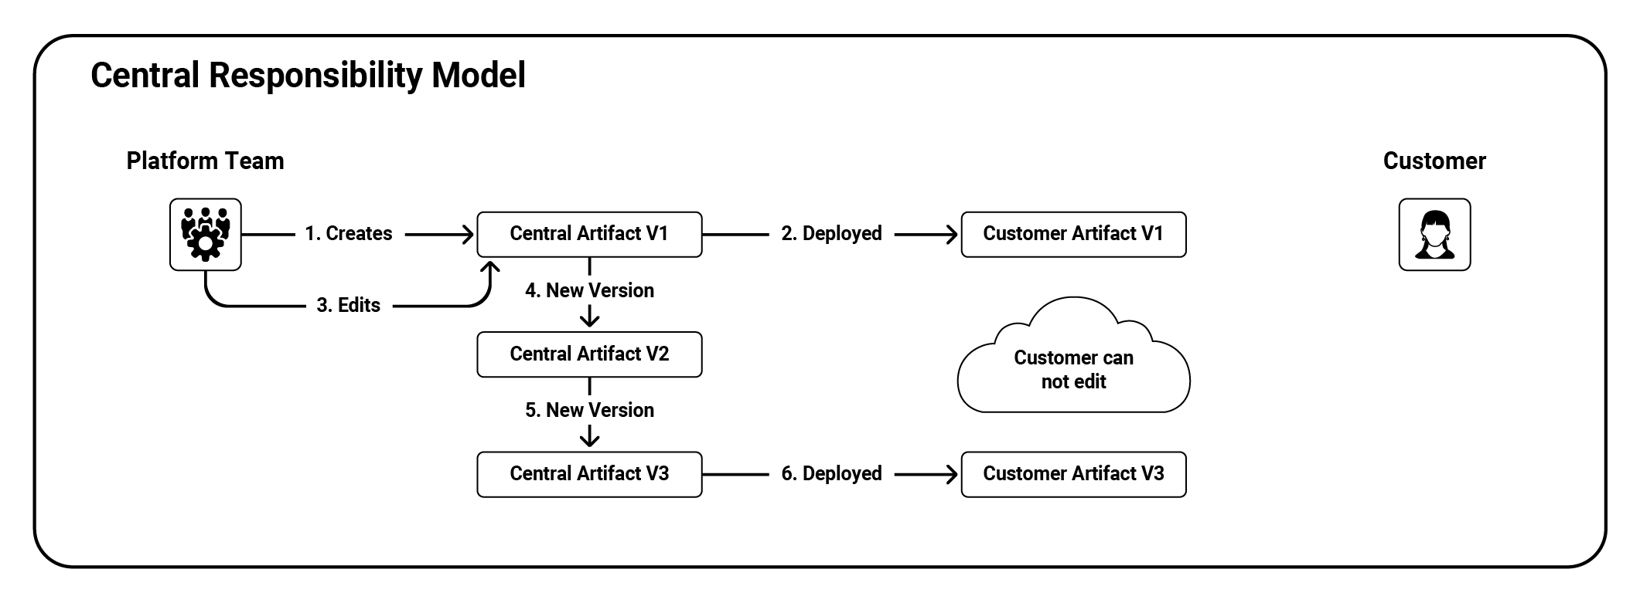

Customization as Feedback
In the chapter "Planning your Internal Developer Platform", we noted that feedback was an important activity to undertake as part of a product mindset.

Metrics like NPS or CSAT are appealing because they can be automated and asynchronous but may be of limited value with small sample sizes. And while scheduling feedback sessions with your customers is relatively easy, since your customers are typically also your colleagues, this process is time-consuming.

Another feedback option is to observe the changes made by customers to the artifacts generated by your IDP. This asynchronous feedback mechanism provides high-quality insights into how your customers want to use your platform.

The idea is similar to desire paths. The ABC News article “What desire paths can tell us about how to design safer, better public spaces” (https://oc.to/tVhtZ4) provides this definition:

A desire line, or desire path, is an unplanned trail that forms as a result of traffic, either by humans or other animals, and often veers away from conventional paths.

You may have seen desire paths yourself as dirt tracks that cut a more direct line between paved paths or through vegetation.

The same idea applies to the artifacts produced by your IDP. Suppose your customers have edited them to suit their purposes. Those edits must be considered valuable feedback indicating that the source artifacts may require modification to support their intended use case.

The Responsibility Triad
You will have three competing concerns as you develop your IDP, captured in the responsibility triad:
- To have many artifacts
- To centrally update existing artifacts
- To have end-users modify their artifacts
In practice, you can optimize any two concerns of the responsibility triad:
- You can have many artifacts and update those artifacts over time. However, customers will have limited ability to modify those artifacts.
- You can have many artifacts and allow customers to modify those artifacts. But you'll have limited ability to update those artifacts centrally.
- You can centrally update artifacts and have customers modify them. But you will only be able to support a few artifacts.

Platform teams must plan for the trade-offs imposed by the responsibility triad; otherwise, teams will unexpectedly paint themselves into one of its corners. There are common strategies for platform teams to implement that ensure the trade-offs are intentional.

Initially, your mission statement must limit the number of created artifacts. Deploying too many artifacts without building the muscle to update those artifacts will leave you with a graveyard of good intentions.

Policies or other restrictions that limit how much customers can edit shared responsibility artifacts reduce the burden of centrally pushing changes. For example, if customers could edit steps 2 and 3 in a deployment process, while steps 1, 4 and 5 are read-only, the platform team could reliably publish updates to the read-only steps without affecting customer modifications.

Providing read-only processes but supporting customer-edited variables is a specialized policy that allows customers to customize their artifacts while ensuring the platform team has a stable target for centralized updates.
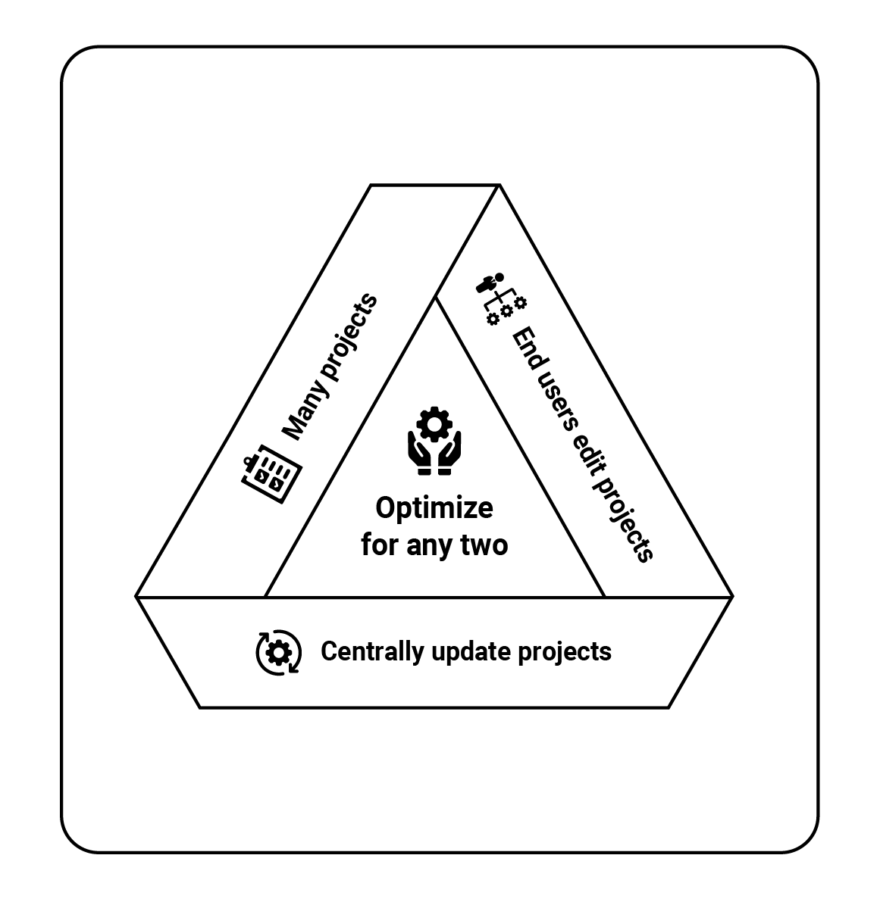
Maintaing multiple versions of your artifacts allows you to add new features to later versions while distributing only critical fixes to previous versions. The SemVer versioning scheme, which uses a x.y.z scheme, captures this idea as major version (or x version) increment. This allows your customers to treat artifact updates like software updates and schedule the integration of new major versions when needed.

Preferencing the customer responsibility model over the shared responsibility model limits the burden on the platform team to resolve conflicts in edited artifacts. The centralized responsibility model also reduces the conflict burden but has the downside of potentially making the IDP a blocker for your customers.

Passing the responsibility to merge changes to the customer has the effect of outsourcing the work of resolving conflicts. This strategy relies heavily on your feedback channels, as this is how you make your customers aware of any pending changes and the urgency with which to perform updates.

The one plan that will eventually fail is to try and deploy a vast number of customizable artifacts and then try to centrally maintain them over time. An IDP is only as valuable as its ability to affect change at scale, and keeping the responsibility triad in mind as you develop your IDP ensures its scalability over the long term.

Example Checklist
This example checklist lists artifacts produced by the IDP and defines the responsibility model associated with each. Strategies for minimizing the impact of customer-edited artifacts are noted, with policies limiting changes or the process of updating artifacts delegated to the customer.

Artifact | Responsibility Model
Database backup scripts | Centralized
Microservice deployment processes | Shared with updates pushed centrally.
Microservice bootstrap code projects | Customer
Virtual Machine creation and destruction scripts | Centralized
Serverless deployment process | Shared with policy enforcing required approval and reporting steps.
Linux app deployment process | Shared with customers pulling in changes.

Conclusion
DevOps teams have always been able to duplicate artifacts, as most tools have some form of copy-and-paste functionality. While building high-quality upstream artifacts is an essential function for any platform team, much of the value derived from an IDP is its ability to distribute updates while still allowing customers to edit their artifacts.

The customer, shared, and centralized responsibility models allow platform teams to be transparent about who is responsible for maintaining long-lived artifacts. While allowing customers to edit their artifacts is an effective strategy against the platform team becoming a blocker, the responsibility triad shows that they come at the cost of being able to update the artifacts or deploy large numbers of them centrally.

Making deliberate decisions around which responsibility models to use for which artifacts, outsourcing conflict resolution, versioning artifacts, and implementing policies ensures that your IDP can continue to operate at scale without eventually being overwhelmed by manual update processes.

The Ten Pillars of Pragmatic Deployments
The shift-left mentality is a valuable guide when determining which steps in the DevOps lifecycle to codify and scale with your IDP. Identifying problems late in the lifecycle and implementing common strategies to resolve them earlier reduces cost and increases velocity. Or, following the motto of Extreme Programming:

If it hurts, do it more often.

Exact numbers around the value of finding bugs earlier are hard to come by. The post “Everyone cites that 'bugs are 100x more expensive to fix in production' research, but the study might not even exist” (https://oc.to/rLmuBw) references research from Hillel Wayne that questions the validity of this commonly cited metric. However, the byline of that article concedes, "It's probably still true, though, says formal methods expert."

While it doesn’t provide meme-worthy quotes, the report “The Economic Impacts of Inadequate Infrastructure for Software Testing” (https://oc.to/Tq1Zlh), prepared for the National Institute of Standards and Technology (NIST), performed a case study in the financial services sector to estimate the economic impact of inadequate infrastructure for software testing, finding:

The major benefits developers cited from an improved infrastructure were direct cost reduction in the development process and a decrease in post-purchase customer support. An additional benefit that respondents thought would emerge from an improved testing infrastructure is increased confidence in the quality of the product they produce and ship.

Identifying issues early in the DevOps lifecycle means identifying them while planning new features, writing and testing code, or as part of your Continuous Integration and Delivery (CI/CD) pipeline. The remainder of the DevOps lifecycle takes place after code is deployed to production, which are the lifecycle stages that issue identification and rectification is ideally moved out of.

Your CI/CD pipeline is a desirable target for your IDP because this process should be mostly automated, allowing DevOps teams to apply improvements at scale. But, more importantly, your existing CI and CD platforms have likely already solved many of the requirements that enable automation:

- They provide an execution environment (in the form of agents or workers) to run automated scripts and applications.
- They have an established process for maintaining authentication and authorization.
- They have existing access to your critical infrastructure.
- Existing operations teams support them.
- Their pipelines are easily modified to include new steps, or triggers are used to provide hooks into existing workflows.
- DevOps teams are already familiar with them.

The chapter "Planning your Internal Developer Platform" recommends clearly defining your IDP's mission to ensure the focus of the platform team on a specific, achievable outcome. This mission statement has two parts: non-functional requirements providing a high-level description of the outcome and functional requirements that describe how the feature works.

While functional requirements align with DevOps teams' specific processes and goals, non-functional requirements represent common high-level scenarios applicable to a wide variety of teams.

This chapter describes ten non-functional requirements, or pillars, related to CI/CD pipelines. These pillars represent desirable traits to prompt discussions with customers or standardize across your customer base.

Pillar 1. Repeatable Deployments
Software teams are deploying software to production more frequently than ever. They also make deployments to pre-production environments as part of their deployment pipeline.
To be confident when you change software at high velocity, you need a mix of methods such as test automation, exploratory testing, self-beta testing (drinking your own champagne), and other techniques to confirm the release-ability of your software.
These techniques are only helpful if what you deploy to production is the same as what you deploy to your other environments.
The pillar of repeatable deployments requires you to deploy the same thing in the same way each time you deploy an application version.

General Deployment Concepts
To understand repeatable deployments, we need to fine-tune our definitions. We must be precise with some terms relating to deployment pipelines and the timing of different stages.

Deployment pipelines
A deployment pipeline starts when you commit code to a source code repository, and it follows the change to the production environment.
Every activity needed to progress the change is part of your deployment pipeline. Code reviews, builds, testing, release management, sign-offs, and deployments are all included, whether manual or automated.

Continuous Integration
The most common entry point to a deployment pipeline is continuous integration (CI). This is the process of committing code, compiling it, running tests, packaging a new application version, and publishing it.
Dave Farley and Jez Humble recommend changes are regularly integrated into the main branch in source control (hence the "continuous" in "continuous integration"). Many teams use the term more loosely to define their automated build process.

Continuous Delivery
While continuous integration is the automation of creating a deployable package each time the code changes, Continuous Delivery (CD) extends this through to deployment automation and monitoring.
You might still have some manual stages in your deployment pipeline, such as exploratory testing or an approval process. But you should automate all deployment steps as this helps you achieve repeatable deployments.
Using the same deployment process for all environments means it gets tested as often as the application.

Continuous Deployment
Continuous Deployment takes CI/CD a step further, removing all manual intervention to create a fully automated commit-to-consumer workflow. The deployment pipeline automatically rejects a bad application version and deploys all good versions to production without manual approvals.

CI/CD
CI/CD refers to the combination of continuous integration with Continuous Delivery or Continuous Deployment.
Teams commonly deploy to the development environment without manual intervention but allow people to control when they deploy to subsequent environments.
CI/CD pipelines don't seem that blog-worthy these days, but when someone talks about their pipelines, it is usually in the context of having achieved continuous deployment. While achieving continuous deployment is no simple feat, I don't recall a conversation with an organization where continuous deployment was a stated goal.
In the test environment, quality assurance (QA) staff validate changes, product owners review new functionality, security teams probe for vulnerabilities, etc. When everyone is happy that the changes meet their requirements, they can promote the application version to production.
The production environment is the final destination. It's where end users can use the application.

What is an Environment?
Environments represent the boundaries between copies of individual applications or entire application stacks and their supporting infrastructure.
Each environment should reasonably reflect the production environment. This ensures the application will behave consistently and avoids surprises when you go live.
You might frequently deploy to earlier environments, trading stability for faster feedback. Your users expect production environments to be stable.
You progress deployments through environments to increase confidence that you can deliver a working solution to the end user.
We call the canonical set of environments development, test, and production. The table below describes the characteristics of these environments:
Environment | Description | Deployment Frequency | Stability / Confidence
Development | Used by developers to test individual changes as they are implemented. | High | Low
Test | Used by developers, QA, and non-technical staff to validate that changes meet requirements. | Medium | Medium
Production | Accessed by end users to consume the publicly available instance of the applications. | Low | High
Although you can have any number of environments with different names, we use this set of environments in this book.

What is a Deployment?
We've talked about deploying "applications" to environments, but to appreciate how you achieve repeatable deployments, we must be more specific about what we deploy.
A deployment should include a snapshot of:
- The application version
- The deployment process
- The variables used to configure the application for an environment
- Inline scripts that support the deployment and configuration of the application and infrastructure
This combination of these values forms a release, which captures the current deployment state. The release snapshot ensures you use the same snapshot for the release, even if you change the process, variables, or scripts during environment progression.
Without a release snapshot, you could deploy a tested application version using an untested deployment process, resulting in a problem in your production environment.

Pillar 2. Verifiable Deployments
The repeatable deployments pillar describes how promoting releases through environments increases confidence in the application version and deployment process.
The pillar of verifiable deployments describes the various techniques you can use to verify a deployment when it reaches a new environment.

General Testing Concepts
Testing is a nebulous term with often ill-defined subcategories. We will not attempt to provide authoritative definitions of testing categories here. We aim to offer a high-level description of common testing practices and highlight those you can use when you deploy.

Testing Outside of Deployments
We consider unit tests part of the build pipeline. They're closely tied to the code and must pass for the build server to publish the application package.
You might also run integration tests during the build process to verify components interact as expected. Sometimes, you might use a test double instead of a real component to improve reliability. Otherwise, you might spin up the dependencies as part of the test.
The tests run by the build server should result in a high-quality application package being published, with bad application versions prevented from progressing.

Testing During Deployments
Tests that require a live application or application stack to be accessible are ideal candidates to run as part of a deployment process.
Smoke tests are quick tests designed to ensure you deploy applications and services correctly. Smoke tests implement the minimum interaction required to ensure services respond correctly. Some examples include:
- An HTTP request of a web application or service to check for a successful response.
- A database login to ensure the database is available.
- Checking that a directory has been populated with files.
- Querying the infrastructure layer to ensure the expected resources were created.
Integration tests can run as part of your build or deployment processes. Integration tests validate that multiple components are interacting as you expect. You may include test doubles with the deployment to stand in for dependencies, or the tests may verify two or more running component instances.
Examples include:
- Signing into a web application to verify that it can interact with an authentication provider.
- Querying an API for results from a database to ensure that the database is accessible via a service.
End-to-end tests provide an automated way of interacting with a system like a user would. These can be long-running tests following paths through the application that require most or all application stack components to work correctly. Examples include:
- Automating the interaction with an online store to browse a catalog, view an item, add it to a cart, complete the checkout, and review the account order history.
- Completing a series of API calls to a weather service to find a city's latitude and longitude, getting the current weather for the returned location, and returning the forecast for the rest of the week.
Chaos testing involves deliberately removing or interfering with the components that make up an application to validate that the system is resilient enough to withstand such failures. You can combine chaos testing with other tests to verify the stability of a degraded system.
Usability and acceptance testing often involve a human using the application to verify that it meets the requirements. The requirements can be subjective, for example, determining if the application is visually appealing. Or the testers may be non-technical and don't have the option of automating tests. The manual and subjective nature of these tests makes them difficult, if not impossible, to automate, meaning a working copy of the application or application stack must be deployed and made accessible to testers.

Pillar 3. Seamless Deployments
When you deploy your application, you need to switch users from the old application version to the new one. The pillar of seamless deployments discusses approaches to reducing the user impact when you update the application.
One of the easiest ways to deploy an application without impacting users is to use planned maintenance windows. You can schedule these to occur outside of the users' regular working hours to minimize disruption to their work.
This approach is less practical if you have users in many time zones, need to minimize downtime, or want to deploy more often.
In these cases, you can use some common deployment strategies to deploy new application versions seamlessly.

Seamless Database Deployments
No discussion on seamless deployments can begin without first addressing the issue of database updates.
A fundamental aspect of most seamless deployment strategies involves running two versions of your application side by side, if only for a short time. If two versions of the application access the same database, all updates to the database schema and data must be compatible with both versions. We refer to this as backward and forward compatibility.
However, backward and forward compatibility is not trivial to implement. In the presentation Update your Database Schema with Zero Downtime Migrations (https://oc.to/BzKUy3), based on chapter 3 of the book Migrating to Microservice Databases (https://oc.to/nLvrV4), Edison Yanaga walks through the process of renaming a single column in a database. It involves six incremental updates to the database and application code, and you must deploy each in sequence.
Seamless deployments involving a database require careful planning, many small steps to roll out the changes, and tight coordination between the database and application code.
You can find more database techniques in Refactoring Databases (https://oc.to/huM7G3) by Scott W. Ambler and Pramod Saalage.

Deployment Strategies
There are several ways to manage a cutover between an existing and a new application version. The right deployment strategy can help you achieve seamless deployments.

Recreate
The recreate strategy doesn't provide a seamless deployment. It's included here as the default option for most deployment processes. This strategy involves either:
- Removing the existing deployment before deploying the new version.
- Deploying the new version over the top of the current one.
Both options result in downtime between the existing version being stopped or removed and the new version starting. However, because you don't run the current and new versions concurrently, your database upgrade won't need to satisfy backward and forward compatibility requirements.

Rolling Updates
The rolling update strategy involves incrementally updating instances of the current deployment with the new deployment. This strategy ensures at least one application instance is always available during the rollout.
Your load balancer will send users to instances with its usual balancing pattern, so as the rollout progresses, more users will be moving onto the new application version. You can also take each instance out of the load balancer before you update it, so requests aren't dropped during the deployment.
With rolling updates, your database will need to maintain backward and forward compatibility, as during the rollout it will receive connections from both the old and new application versions.

Canary Deployment
The canary deployment strategy is similar to the rolling update strategy in that both incrementally expose more end users to the new deployment over time.
With canary deployments, you create a small group of users who get new versions before everyone else. This group may contain users who opt-in to get early access, represent a segment of your business (such as free-tier users), or be an algorithmic sample.
The first step of a canary deployment is to update the application instance used by your canary users. Once you have collected information from this group, you can decide whether to continue the rollout. This may be a human decision, or you might automate it based on monitoring data or log files.
Canary deployments allow you to halt the rollout and revert to the previous application version if you find a problem in the sample group.

Blue/Green Deployments
The blue/green strategy involves deploying the new version (the green version) alongside the current version (the blue version) without exposing the green version to traffic. After you deploy and verify the green version, traffic is cutover from the blue to the green version. You can remove the blue version when the green version handles all traffic.
Any database changes deployed by the green version must maintain backward and forward compatibility. Even when the green version is not serving traffic, the blue version gets exposed to database changes.
This deployment strategy requires additional infrastructure during the deployment process. However, this can be created and destroyed automatically or used as a cold standby, depending on your needs and cost constraints.

Session-draining
You can use the session-draining strategy when applications maintain states tied to a particular application version.
This strategy is similar to the blue/green strategy as it also means you deploy the new version alongside the current version, running both side by side. Unlike the blue/green strategy, session-draining will direct only new sessions to the new version while the existing one continues to serve traffic for existing sessions.
You need the same infrastructure and clean-up requirements for blue/green and session-draining strategies.
Any database changes must maintain backward and forward compatibility because the old and new application versions run side-by-side.

Feature Flags
The feature flag strategy involves building functionality into a new application version and using a toggle or feature flag to control its visibility. This process lets you control feature visibility without needing a deployment.
In practice, one of the strategies above is used to deploy a new application version with flaggable features. Hence, the feature flag strategy is a complement to those other strategies.

Feature Branch
The feature branch strategy allows developers to deploy an application version with changes they are working on, usually in a non-production environment, alongside the main deployment.
Maintaining database backward and forward compatibility may not be necessary with feature branch deployments. Because feature branches are short-lived for testing, it is acceptable that each deployment has access to an isolated test database.

Pillar 4. Recoverable Deployments
Despite your best efforts with repeatable and verifiable deployments, you'll always need to handle production bugs. When this happens, being able to quickly and safely recover is crucial.

Rolling Back or Forward
Recovering from an undesirable deployment means choosing whether to roll back to a previous good application version or roll forward to a new version that returns the environment to a desirable state.
Either solution works with stateless applications, but you must treat rollbacks with care when there's a database involved.
This is the advice from the FlyWay project (https://oc.to/lVr2Zn):
While the idea of undo migrations is nice, unfortunately it sometimes breaks down in practice. As soon as you have destructive changes (drop, delete, truncate, …), you start getting into trouble. And even if you don't, you end up creating home-made alternatives for restoring backups, which need to be properly tested as well.
RedGate offers this advice for database rollbacks (https://oc.to/sbc7WW):
Rather than investing time and energy into rollback planning, an alternative is to follow an approach that keeps you moving forward.
The blog post “Pitfalls with SQL rollbacks and automated database deployments” (https://oc.to/WRvLE4) has this advice:
More often than not, the effort to successfully rollback a deployment far exceeds the effort it would take to push a fix to production.
For these reasons, when deployments involve database changes, rolling forward to recover from an undesirable deployment is a logical choice.

Rolling Back
If you have achieved the pillar of repeatable deployments, you can roll back by re-running a previous deployment. Redeployments are possible because the package versions, scripts, and variables are all captured by a repeatable deployment.
Rollbacks are also an explicit feature of several seamless deployment strategies:
- Canary deployments implement rollbacks by redirecting all traffic from the new deployment to the current deployment.
- Blue/green deployments can roll back a deployment by cutting traffic back to the blue stack.
- Session-draining deployments can redirect new sessions to the current deployment and optionally kill any sessions in the new deployment.
Rollbacks have the following benefits:
- You can fix a deployment issue, without writing code, by rolling back to a previous deployment.
- A rollback leaves the system in a known, verified state.
- You can measure the time to complete a rollback in non-production environments.
Rollbacks have the following disadvantages:
- Rollbacks are all-or-nothing operations. You can not roll back individual features, only entire deployments.
- You need to test rollbacks as part of the deployment process to ensure they work as expected, which increases the complexity and time of the deployment process.
- If a rollback fails, you will likely need to resolve the issue by rolling forward.
- Database rollbacks require special consideration to ensure data is not lost.

Rolling Forward
Rolling forward is another way to describe performing a new deployment. In this case, the new deployment will only contain the fixes required to restore an environment.
Rolling forward has the following benefits:
- All deployment strategies inherently support rolling forward with or without a database.
- Teams gain experience in rolling forward with every deployment.
- You can choose the scope of a change or fix when rolling forward.
- Multiple deployments can be made in succession while rolling forward to resolve an undesirable deployment.
Rolling forward has the following disadvantages:
- Rolling forward typically requires a developer to implement a fix to include in the next deployment.
- You must have a short lead time for changes. Otherwise, you'll be tempted to skip environments to expedite the fix.
- The production environment will be left in an undesirable state for as long as it takes to develop and deploy the next version.

Pillar 5. Visible deployments
Tracking which application version you deployed to each environment can be challenging. It is not practical to review the files on the disk or the structure and data in the database, as this is like trying to work out what mix of colors produced a tin of paint.
Having a view of environments and application versions is crucial to understanding:
- What features you've provided to your customers
- What features are being tested
- What issues you've fixed
- The history of any changes
Listed below are the details required to gain complete visibility into the state of your deployments.

Commit Messages
Commit messages capture the intention of source code edits, describing the changes made and who made them. These messages are invaluable when trying to understand at a low level what changes made it into a particular version of a package.

Issue Tracking
Source code commits often resolve an issue documented in a dedicated issue tracker. These issues allow you to describe, discuss, and track bugs. A unique identifier references each issue.
Capturing the issue IDs related to changes in a package version and any deployment that includes that package version provides insight into the issues resolved in any deployment.

Build Logs
A typical CI/CD pipeline will have a build server that builds, tests, and packages an application. The log files for these builds contain a wealth of information, such as:
- Which tests passed
- Which tests were ignored
- Which dependencies were included
- What packages were created
You can quickly review these log files if you have a link to the build information from the deployment.

Library Dependencies
Almost every application deployed today combines custom code with third-party, often open-source, libraries. These external libraries provide useful features but can be a source of bugs or security vulnerabilities. Understanding all the application's dependencies is essential for security, auditing, and debugging.
Legislation such as the Cyber Resilience Act (CRA) and the requirements of the NIST “Software Supply Chain Security Guidance Under Executive Order (EO) 14028” (https://oc.to/T3b11u) may compel you to produce Software Bill or Materials (SBOMs) to accompany your application, making the management of library dependencies a requirement of your CI/CD pipeline.

Release Versions
A release version captures a snapshot of the above information, along with the deployment process, package versions, variable values, and scripts. You deploy this release version to each environment.
Displaying the release versions deployed to each environment provides a high-level view of the state of your deployments. With this information, the deployment of releases to environments is available for anyone to see. By drilling into the details of a release, you can see the commit messages, issues, dependencies, and links to the CI builds.

Pillar 6. Measurable Deployments
The deployment pipeline's primary goal is getting your software into your customers' hands. To understand how well your deployment pipeline is performing, you need to measure the metrics that define success for you.
Having measurable deployments means defining useful metrics, reliably collecting them, and surfacing them in an easy-to-understand format.
Some metrics you can use to track deployments are:
- Deployment frequency: How frequently do you deploy to production?
- Lead time for changes: How long does it take for a code change to be deployed to production?
- Time to recover deployment: How long does it take to recover from a failed deployment?
- Deployment fail rate: What is the ratio of failed to successful deployments?
- Change fail rate: What is the ratio between hotfix and regular deployments?
- Deployment duration: How long does each deployment take?

Pillar 7. Auditable Deployments
If the visible deployments pillar is about surfacing the current state of your environments and the changes made as part of the release, then auditing is about tracking those involved in the deployment process over time.
Auditing allows teams to see a history of all deployment activity, such as:
- Deployments to environments
- Changes to the deployment process
- Changes to environments
- Who approved a deployment
- The state of an environment at some point in the past
For audit events to be helpful, they must be searchable, filterable, and exportable to support reporting and analysis.

Pillar 8. Standardized Deployments
Just as repeatable deployments build confidence as you promote a release across environments, standardizing deployment processes across different projects allows teams to confidently use proven solutions.
Your IDP is an ideal solution for standardizing deployment processes across DevOps teams. Much of what we have discussed in this book directly applies to planning, creating, and maintaining standardized deployment processes.
As noted in the chapter introduction, CI/CD pipelines are a logical place to embed the automated and scalable functionality that platform teams are responsible for delivering. In this case, your IDP is responsible for providing the pillar of standardized deployment pipelines, and the pipelines will then embed other appropriate pillars.

Pillar 9. Maintainable Deployments
Getting your deployments to the production environment is just the beginning. Diagnosing issues, collecting logs, performing backups, restarting services, rotating keys, and testing connections are just some Business as Usual (BAU) operations tasks that keep your applications running and your customers happy.
While you could SSH or RDP into a server and start poking around, each change you make causes your environment configuration to drift, making it harder to implement repeatable deployments. It is also difficult to track changes, verify that they worked, and audit who changed what.
Maintenance tasks should be repeatable, verifiable, visible, measurable, auditable, standardized and coordinated - just like deployments. Maintenance tasks represent the business knowledge required to keep your deployments running and should meet the same standards as your deployment processes.

Pillar 10. Coordinated Deployments
Deploying a package to an environment is just one small part of the deployment process. Often, you need to coordinate deployments with other business processes to ensure:
- The right people have given their approval
- Interested parties get notified of the success or failure of a deployment
- Deployments proceed in the correct order _ Deployments can only occur during specific times
- High-priority deployments take precedence over low-priority ones
- Deployments get scheduled to take place at a predetermined time
- External events can trigger deployments
- Deployments can trigger external events
A deployment process may be a single component in the broader ecosystem of business process management tools. The ability to orchestrate deployments from third-party platforms and report results back allows teams to manage complex deployments as part of a broader business process.

Example Checklist
This example checklist provides a table for the platform team to note how to implement the pillars with functional requirements.

The values assigned to the pillars are subjective but capture their relative importance.

You then plot these values on a spider (or radar) chart. This visualization identifies both essential and deprioritized pillars.

The decision not to implement a feature may be as important as the decision to implement one, and the combination of the checklist and spider chart surfaces both decision types.

Repeatable | 3 | Need to allow all engineering leads to promote applications to production with a single click.
Verifiable | 2 | Browser-based tests must be run in the staging environment and optionally in production as a debugging tool.
Seamless | 2 | Blue/green deployments in production.
Recoverable | 2 | Rollbacks are performed by reverting traffic to the blue stack
Visible | 2 | Need to quickly find production versions of applications.
Measurable | 0 | Not a priority
Standardized | 4 | Need golden paths for Kubernetes, Lambda, and VM deployments.
Maintainable | 3 | One-off scripts for common DB operations like regenerating indexes.  Smoke test script to hit API, web page, and database login.
Coordinated | 4 | Production deployments are scheduled after hours.  Email report of deployment success or failure.
Auditable | 3 | Must track changes to the deployment process and the deployments to support ISO 27001.

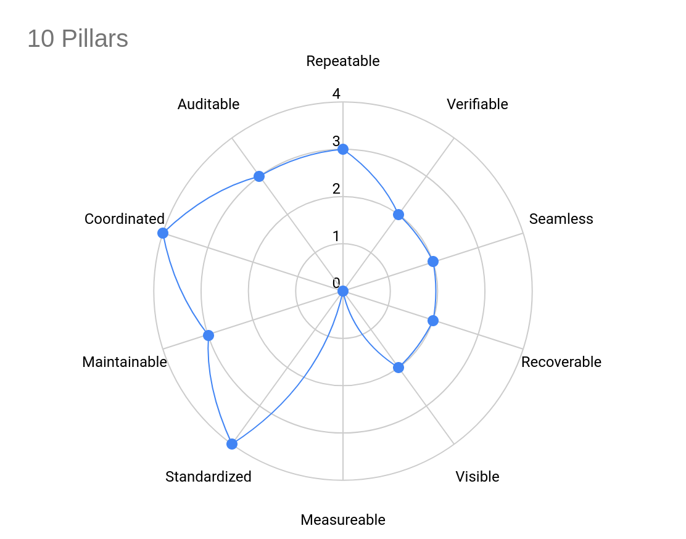

Conclusion
Many IT departments have fallen into the trap of being order-takers, dutifully asking how high when asked to jump. As a platform team member, you have a unique opportunity to lead discussions regarding best practices and the future vision of your DevOps teams.

The ten pillars in this chapter provide a set of non-functional requirements relating to CI/CD. These pillars are helpful in discussions with your customers and inspire them as you move towards a more holistic approach to software delivery.

The sample checklist reinforces this holistic approach by presenting the pillars as a spider chart, clearly identifying which pillars you are considering and which you are not. Capturing all the choices that influence your processes helps to keep your focus on your mission as a platform team.

Epilogue
Platform engineering is an exciting new paradigm in the field of DevOps, and the platform teams that implement this discipline have a unique opportunity to effectively run a startup in their own company as they create an IDP as an internal product.

To be successful, platform teams must adopt a product mindset, which involves:

- Articulate your IDP's value to high-level stakeholders, who are ultimately responsible for investing in your ideas.
- Gathering and inspiring ideas for how your IDP will support DevOps teams to achieve their goals while removing pain points from existing processes.
- Establishing the support, feedback, and internal marketing processes to keep your customers happy and informed.
- Building feedback loops to ensure your priorities align with your customers.
- Clearly articulating the responsibilities of the platform team and your customers to update and maintain the artifacts generated by your IDP.
- Understanding the pillars of a holistic DevOps lifecycle and sharing those insights with your customers.

By following the processes outlined in this book, organizations looking to establish a platform team benefit from a set of activities and practical checklists that ensure the product you build improves DevEx and the performance of your DevOps teams for many years to come.

